Product Strategy Deep Dive: AI Skill Tutor — Competitive Landscape, Product Options & Recommended Path

Executive Summary
The AI career development market represents a $93 billion convergence opportunity across five overlapping segments — AI career coaching ($6.69B), personalized learning ($9.15B), skills assessment ($5.8B), newsletters ($17.8B by 2028), and professional development ($56.89B). Despite this scale, no competitor currently occupies the career-specific, full-learning-system quadrant: a product that combines daily AI news briefing, AI tutoring, skill verification, and portfolio building tailored to a specific professional role. This whitespace is the strategic opportunity for myaiskilltutor.com.
Across four product options evaluated — personalized newsletter, AI tutor chatbot, skill verification platform, and hybrid bundle — a weighted decision matrix scores newsletter-as-wedge highest at 4.1 out of 5.0. The newsletter wins on speed to market (2-4 weeks), capital efficiency (93% margins at 50K subscribers), and monetization velocity ($20-50 CPM advertising, 20-45% affiliate commissions on AI tool recommendations). It also serves as the ideal acquisition engine for the broader platform: daily engagement builds habit, usage data personalizes the AI tutor, and demonstrated learning outcomes populate the portfolio layer.
The current $49.99/month pricing sits 67% above comparable AI education products. Benchmarks from Duolingo Max ($29.99/mo), Codecademy Pro ($39.99/mo), and Coursera Plus ($33/mo annualized) suggest a tiered structure: $19.99/mo for newsletter-only, $29.99/mo for the full platform, and $299/year annual (17% discount) would optimize conversion and retention.
The recommended 18-month roadmap proceeds in three phases: Phase 1 (Months 1-3) launches a career-specific newsletter for 2-3 verticals (performance marketing, product management, operations) to validate engagement; Phase 2 (Months 4-9) integrates an AI tutor layer for the top two verticals; Phase 3 (Months 10-18) adds portfolio verification and an employer-facing portal. The retention flywheel — daily newsletter habit → tutor engagement → portfolio proof → employer interest → subscriber motivation — compounds defensibility over time.
On positioning, the analysis recommends a hybrid messaging framework: opportunity-led (AI-skilled workers earn 10-20% more), with fear-based hooks for urgency (job displacement risk has 70% higher CTR), and peer-based social proof for conversion. The “My AI Skill Tutor” name is functional but generic; a shorter, habit-oriented brand would better communicate daily utility over episodic education.

1. The Competitive Landscape
The AI upskilling market is not a single battlefield. It is a set of overlapping arenas — each with its own incumbents, economics, and structural blind spots. For myaiskilltutor.com, understanding where these arenas intersect and where they leave gaps is the foundation of every product decision that follows. This chapter maps the terrain: the market’s scale and trajectory, the five distinct competitive zones that define it today, and the whitespace those zones collectively reveal.

1.1 Market Size and Growth Dynamics
The convergence of AI adoption and workforce anxiety has created a rare market condition: multiple multi-billion-dollar segments growing simultaneously at double-digit rates, all serving the same fundamental need — helping workers stay relevant as AI reshapes their roles. The AI career coaching market alone is valued at $5.48 billion in 2025 and projected to reach $6.69 billion by 2026, growing at 22.3% CAGR ¹. This is the narrowest definition of the space. The broader AI-powered personalized learning market, which includes adaptive content delivery, intelligent tutoring, and skills assessment, stands at $9.15 billion in 2025 and is projected to expand to $291.85 billion by 2035 at a 41.5% CAGR ². These figures describe fundamentally the same user — a working professional who needs to acquire AI skills — but capture different slices of how that need is monetized.
The skills assessment market adds another $5.8 billion in 2025, growing at 12.1% CAGR toward $16.2 billion by 2034 ³. This segment is critical because it represents the employer side of the equation: the willingness of companies to pay to verify that candidates and employees actually possess the skills they claim. Meanwhile, the global newsletter market is projected to reach $17.8 billion by 2028 ⁴, and the top six AI-focused newsletters already generate a combined $20 million annually in advertising revenue ⁵. This matters because daily AI news consumption is often the first habit in a professional’s upskilling journey — a low-friction entry point that platforms can leverage as an acquisition channel.
Market Segment | 2025 Value | Projected Value | CAGR | Strategic Relevance
AI Career Coaching | $5.48B ¹ | $6.69B (2026) | 22.3% | Core TAM for AI-guided career products
AI Personalized Learning | $9.15B ² | $291.85B (2035) | 41.5% | Long-term TAM for adaptive learning platforms
Skills Assessment | $5.8B ³ | $16.2B (2034) | 12.1% | Employer-side monetization layer
Newsletter / Daily Briefing | $16.08B ⁴ | $27.08B (2035) | 6.4% | Acquisition engine + ad revenue stream
Professional Development (total) | $56.89B ⁶ | $76.25B (2031) | 8.3% | Ceiling spend for B2C learning budgets
These segments do not operate independently. A professional who reads an AI newsletter daily is more likely to enroll in a course, complete a skills assessment, and eventually seek employer recognition for those skills. The platform that owns the earliest touchpoint — the daily habit — gains asymmetric advantage in capturing value from every subsequent step. The market data thus points to an integrated opportunity: a single platform that combines daily AI briefings, personalized tutoring, skill verification, and portfolio building into one career-specific learning system.
The demand-side data confirms this is not speculative. Sixty-five percent of job seekers now use AI tools during their applications, and candidates who engage with AI-powered career platforms experience 38% higher hire rates compared to those who do not ⁷. Seventy-seven percent of workers report that AI has increased their workload, while 47% do not know how to achieve the productivity gains their employers expect ⁸. This gap between AI expectation and AI execution is the market’s driving force. Workers are not looking for more content; they are looking for systems that translate AI news into applied career skills, measured outcomes, and employer-recognized proof.

1.2 The Five Competitive Zones
The competitive landscape fragments into five distinct zones, each solving a piece of the upskilling puzzle but none delivering the integrated experience the market demands. Understanding the strengths and limitations of each zone reveals why a unified approach represents genuine whitespace rather than incremental improvement.
Traditional Learning Platforms. Coursera, Udemy, LinkedIn Learning, and Pluralsight collectively serve over 360 million learners and generate billions in annual revenue ⁹. Coursera alone added 29 million new learners in 2025, with AI course enrollments accelerating to 15 per minute — nearly double the 2024 rate ¹⁰. LinkedIn Learning’s AI Coaching feature has improved completion rates by 35% compared to generic learning playlists, and users with AI coaching are 46% more likely to list in-demand skills on their profiles ¹¹. Yet the structural problem persists: the median MOOC completion rate is 12.6%, meaning 87.4% of enrolled learners never finish ¹². Self-paced design, passive video consumption, and weak personalization remain endemic. While Coursera’s Coach AI assistant maintains a 90% learner satisfaction rating ¹³, and Pluralsight’s Iris offers RAG-based in-video Q&A ¹⁴, none of these platforms solve the core accountability gap. They deliver content exceptionally well; they do not deliver learning systems. Moreover, 88% of generative AI users are non-technical professionals in marketing, operations, sales, and product management ¹⁵— yet traditional platforms remain dominated by technical course catalogs with limited relevance to these roles.
Cohort-Based AI Learning. Maven, Section School, DeepLearning.AI, General Assembly, and Springboard occupy the premium tier of the market, charging $500 to $5,000 per course and achieving 70-96% completion rates ¹⁶. Maven’s AI Product Management certification, taught by instructors from OpenAI and Anthropic, costs $2,500 and has garnered over 1,000 reviews at a 4.8 rating ¹⁷. Section School’s $750 annual subscription bundles 50+ AI courses with its Prof AI teaching assistant ¹⁸. The completion rate advantage is real: cohort-based courses with live instruction, peer accountability, and financial commitment demonstrably outperform self-paced alternatives. But the scalability constraints are equally real. Top instructors can only run three to four cohorts per year, each limited to 20-100 students ¹⁹. Fixed schedules create time-zone conflicts for global professionals, and the $500-$5,000 price range places these programs out of reach for 40% of prospective learners who report cost as their primary barrier ²⁰. The model produces excellent outcomes for those who can afford it and schedule around it — a self-selected minority.
AI Newsletters. The daily AI briefing market is dominated by The Rundown AI (2 million+ subscribers), Superhuman AI (1.5 million+), TLDR AI (920,000+), and The Neuron (500,000+), with combined estimated annual revenue exceeding $20 million from advertising alone ⁵. Engagement rates are extraordinary: The Rundown reports ~50% open rates, Superhuman ~45%, and TLDR AI 44% — all roughly double the 21.5% industry average ²¹. Beehiiv platform data shows newsletter open rates hitting 41%+ across its publisher base in 2025, with 28 billion emails sent to 255 million unique readers ²². The business model is proven: free distribution, ad-supported monetization at $20-50 CPM for AI newsletters, with sponsorship spots frequently sold out ²³. Yet every major player in this space shares a critical limitation: zero career personalization. The same briefing goes to engineers, marketers, executives, and healthcare workers alike. Readers already self-select newsletters by role — developers subscribe to TLDR AI, product managers to Superhuman, executives to The Rundown ²⁴— but no publication offers genuinely personalized content within a single subscription. This structural homogeneity is not accidental; it reflects the advertising model’s incentive to maximize unified audience size for advertiser appeal ²⁵.
Skill Verification Platforms. HackerRank processes approximately 172,800 technical skill assessment submissions daily, supports 55+ programming languages, and serves 25%+ of Fortune 100 companies ²⁶. TestGorilla offers 400+ tests covering a broader range of roles but locks essential features like ATS integrations behind its $400+ per month Plus tier ²⁷. CodeSignal emphasizes certified, research-backed assessments with a standardized Coding Score, though its removal of public pricing and AWS Marketplace listing at $19,000 annually signals a shift toward enterprise-only positioning ²⁸. These platforms share a common orientation: they are pre-employment screening tools, not ongoing skill-building companions. HackerRank’s revenue model is centered on employer-led candidate screening; its practice challenges and free certifications primarily function as lead generation to attract developers who then take employer-sponsored assessments ²⁶. The critical gap is non-technical AI skills. While McKinsey data shows 88% of generative AI users are in non-technical roles ¹⁵, virtually no platform verifies AI fluency for marketers, sales professionals, operations managers, or HR leaders. LinkedIn’s discontinuation of Skill Assessments in 2024 — because “examples of how a candidate applied their skills is increasingly valuable to assess fit” ²⁹— confirms that the old model of multiple-choice testing has failed, but nothing has replaced it for non-technical AI competencies.
AI Tutors and Coaching Bots. The evidence for AI tutoring efficacy is now robust across multiple randomized controlled trials. Google’s LearnLM outperformed human tutors in a 2025 RCT with 165 UK secondary school students, producing a 5.5 percentage point improvement in solving novel problems (66.2% vs. 60.7%) ³⁰. A 2025 systematic review of 21 empirical studies found performance gains ranging from 15% to 35% with AI tutoring tools ³¹. Khanmigo grew from 68,000 to 700,000+ users in one school year — a 10x increase ³². Duolingo Max, priced at approximately $30 monthly, has reached ~1.1 million subscribers with 2x longer sessions and 25% higher self-rated confidence after just three AI video call interactions ³³. In the professional coaching space, CoachHub’s AIMY AI coach achieved 70%+ satisfaction ratings and an 84% continuation rate after users customized their AI coach ³⁴. Yet no product in this category targets working professionals learning career-specific skills. Khanmigo serves K-12 students. Duolingo Max teaches languages. CoachHub AIMY requires enterprise sponsorship and focuses on leadership coaching rather than skill acquisition ³⁵. The professional development market at $56.89 billion ⁶with an AI coaching segment growing at 13.86% CAGR ³⁶has no AI-native tutor purpose-built for individual working professionals seeking to acquire AI skills relevant to their specific career function.
Competitive Zone | Representative Players | Scale | Pricing | Core Weakness
Traditional Learning | Coursera, Udemy, LinkedIn Learning, Pluralsight | 360M+ learners ⁹; 12.6% median completion ¹² | $10-$59/month | Passive content; no accountability; weak personalization
Cohort-Based Learning | Maven, Section School, DeepLearning.AI, Springboard | $8.4B market ¹⁶; 70-96% completion | $500-$5,000/course | Poor scalability; scheduling rigidity; high cost barrier
AI Newsletters | The Rundown, Superhuman, TLDR, Ben’s Bites | 5M+ combined subs; 40-55% open rates ²¹ | Free (ad-supported) | Zero career personalization; no skill building
Skill Verification | HackerRank, TestGorilla, CodeSignal | 172,800 assessments/day ²⁶ | $165/mo-$19K/yr | Pre-employment only; no non-technical AI coverage
AI Tutors | Khanmigo, Duolingo Max, CoachHub AIMY | 700K+ students; ~1.1M Max subs ³² ³³ | $15-$30/month | No product targets working professionals on career skills
The table above crystallizes the strategic challenge. Each zone excels at one dimension of the upskilling problem — content delivery, accountability, daily engagement, assessment rigor, or personalized instruction — but fails at the others. The median completion rate in traditional learning (12.6%) means content alone does not produce outcomes. Cohort-based programs produce outcomes but at $500-$5,000 price points that exclude most professionals. Newsletters achieve daily engagement at scale but deliver no skill transfer. Assessment platforms verify skills but offer no learning path to acquire them. AI tutors demonstrate learning gains but have not entered the professional career-skills market. The opportunity is not to compete with any single zone on its home turf; it is to integrate the best elements of each into a system that none can replicate independently.

1.3 Competitive Positioning Map
The positioning map below plots competitors along two axes: horizontal breadth (from generalist content to career-specific focus) and vertical depth (from passive content delivery to integrated learning systems combining tutoring, assessment, and portfolio verification). The resulting visualization reveals a pronounced clustering pattern and a distinct, unoccupied quadrant.
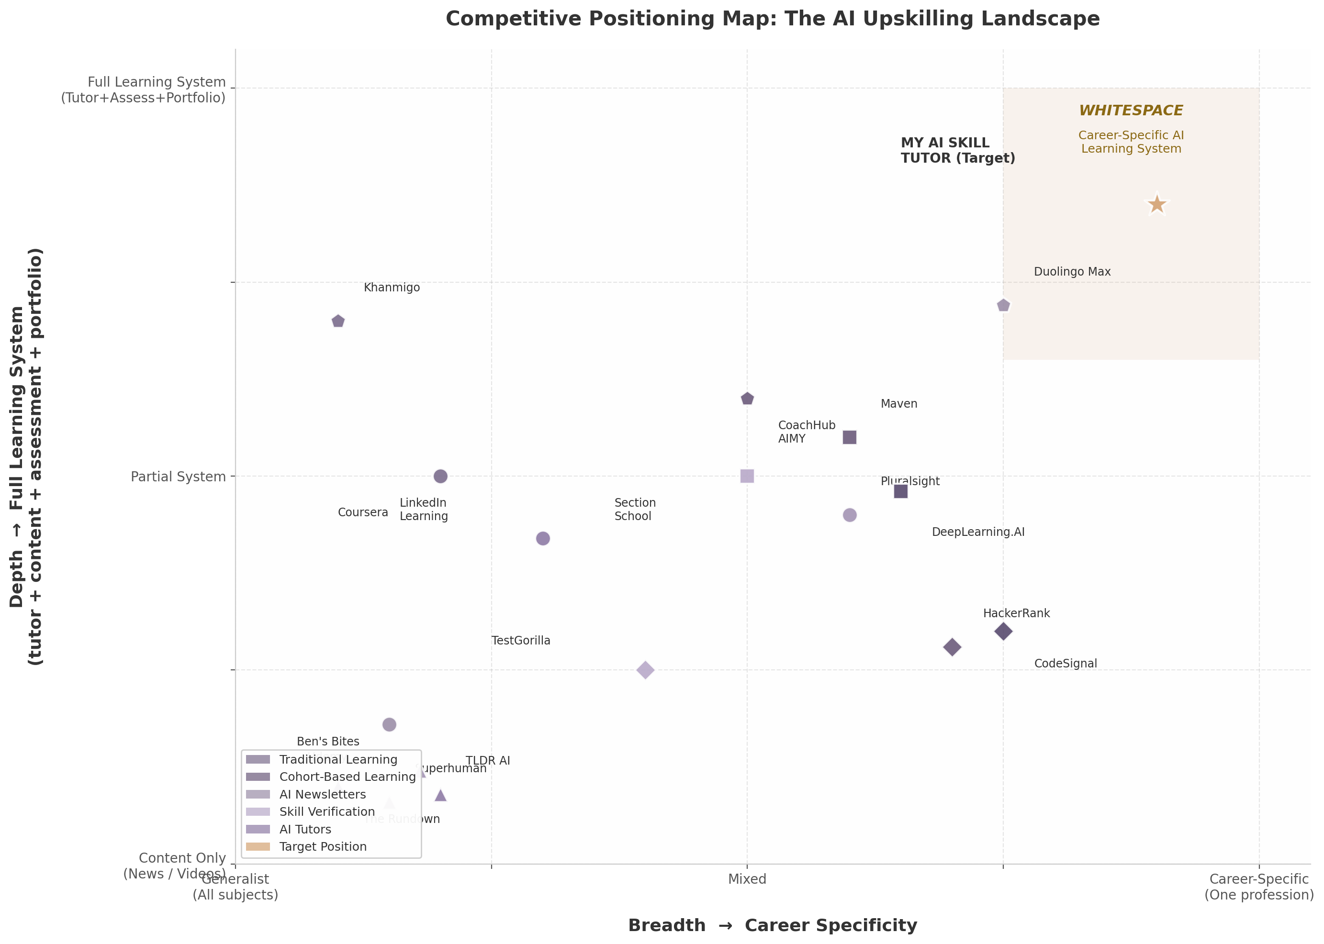
Competitive Positioning Map
Figure 1.1 — 2D competitive positioning matrix: breadth (generalist → career-specific) versus depth (content delivery → full learning system). Bubble shapes indicate category: circles for traditional learning, squares for cohort-based, triangles for newsletters, diamonds for skill verification, pentagons for AI tutors, star for target position. The shaded region marks the identified whitespace.
The competitive landscape clusters into three distinct regions. The bottom-left quadrant is densely populated by generalist content providers: Udemy, the major AI newsletters (The Rundown, Superhuman, TLDR AI), and to a lesser extent Coursera and LinkedIn Learning. These players compete on audience scale and content breadth but offer minimal personalization, no integrated tutoring, and no skill verification. Their business models are optimized for engagement volume, not learning outcomes — a defensible position for advertising and subscription revenue, but not a position that produces measurable skill acquisition.
The center of the map is occupied by players that have added some depth without sacrificing breadth. Maven and Section School bring accountability through cohort structure. CoachHub AIMY introduces AI-powered coaching but requires employer sponsorship and targets generic leadership skills rather than career-specific AI competencies. Pluralsight and DeepLearning.AI narrow the focus to technical skills but remain fundamentally content-delivery platforms with assessment overlays. None of these center-positioned players solve the full stack: daily engagement + personalized tutoring + verified skill demonstration + career-specific relevance.
The top-right quadrant — career-specific breadth combined with full learning system depth — is entirely unoccupied. This is the whitespace. No competitor currently offers a daily AI briefing personalized by career function, an AI tutor that teaches role-specific AI skills, a portfolio builder that captures applied learning evidence, and a verification layer that employers trust. The individual components exist across different competitors; the integrated system does not. Google’s LearnLM demonstrated that AI tutors can outperform human tutors on knowledge transfer ³⁰; Duolingo proved that daily engagement drives subscription revenue at 52.7 million daily active users ³³; The Rundown proved that AI newsletters can acquire 2 million subscribers at ~50% open rates ²¹. The strategic question is not whether each component works in isolation, but whether a single platform can orchestrate them into a career-specific learning system that captures value at every stage of the professional’s upskilling journey.
The positioning map also clarifies what myaiskilltutor.com should not attempt. Competing with Coursera on content breadth would require hundreds of millions in content investment. Competing with HackerRank on technical assessment would mean entering a saturated market with entrenched enterprise buyers. Competing with Maven on premium cohort experiences would replicate the scalability constraints that limit that model’s reach. The viable path is vertical integration: owning the career-specific layer across the full depth stack — from daily news habit through tutoring to verified portfolio — in a segment where no incumbent currently defends. Eighty-eight percent of generative AI users are non-technical professionals ¹⁵, yet the entire competitive landscape is optimized for developers, engineers, and technical specialists. The positioning map reveals not just where competitors are, but where they have collectively chosen not to go — and that unoccupied space is where the largest underserved audience waits.

2. Product Option Evaluation
The preceding competitive analysis revealed a market crowded at the edges but hollow at the center. No single product combines daily relevance, interactive skill-building, and verified proof of competency for working professionals. This chapter evaluates four distinct product architectures against that gap — each with its own risk profile, capital requirements, and defensibility trajectory. The analysis proceeds by examining each option’s definition, strengths, weaknesses, economics, and feasibility, then closes with the strategic tension that must be resolved before any build decision.

2.1 Option A: Personalized Career Newsletter

2.1.1 Product Definition
A daily or weekday AI briefing curated and generated per career vertical — e.g., “AI for Performance Marketers,” “AI for Product Managers,” “AI for Operations Leads.” Each edition filters the day’s AI developments through a role-specific lens: tool recommendations relevant to that function, workflow tutorials using those tools, regulatory updates impacting that sector, and peer benchmarking data. The core promise is relevance — “only the AI news that matters to your job.”
The personalization operates at two levels. First, content selection: a RAG pipeline ingests AI industry sources (product launches, research papers, funding news, policy shifts), retrieves items relevant to each subscriber’s declared role, and generates a ranked digest. Second, content generation: an LLM rewrites each retrieved item with role-specific framing — the same GPT-5 launch announcement reads differently for a marketer (“new ad creative capabilities”) than for a developer (“API changes and rate limits”). This dual-layer approach is technically distinct from the segment-level dynamic content offered by beehiiv or rasa.io, which show or hide pre-written blocks rather than generating unique prose per user ³⁷ ³⁸.

2.1.2 Strengths
Zero direct competitors. Despite over 3,000 AI newsletters launching in a two-year period, exhaustive analysis confirms that not a single major publication offers role-based content personalization ¹⁴. The Rundown AI (2M+ subscribers), Superhuman AI (1.5M+), TLDR AI (920K–1.25M), The Neuron (500K+), and Ben’s Bites (~163K) all deliver identical content to engineers, marketers, and executives alike ¹ ⁴ ⁷ ⁹ ¹¹. Readers self-segment by choosing which newsletters to subscribe to — a TLDR AI for developers, Superhuman for managers — but no publication personalizes within its audience ¹⁵ ³⁰. This structural homogeneity creates a first-mover opportunity for genuine per-user personalization.
Fastest time-to-market. A minimum viable product can be operational within 4–6 weeks: a subscriber signup flow capturing role and seniority, a RAG pipeline over 30–50 RSS feeds, GPT-4o-mini for content generation, and Amazon SES for delivery. Open-source implementations of this exact architecture are publicly available and production-tested ³⁹ ⁴⁰. The rasa.io platform has proven the same technical pattern at scale — sending 1 million unique emails daily for association clients ³⁸.
Lowest customer acquisition cost. Newsletters acquire subscribers through content virality, not paid advertising. AI newsletters report extraordinary engagement rates — 40–55% open rates versus the 21.5% industry average — indicating that subscriber word-of-mouth is unusually powerful ¹⁸ ¹⁹. The top newsletters grew to seven-figure subscriber counts with minimal paid acquisition: The Rundown added ~10,000 subscribers per day organically through 2025 ²¹. Lenny Rachitsky, whose newsletter reached 1.2 million subscribers, stated that “paid ads, SEO, biz dev — none of it really did a damn thing. Word of mouth was the biggest lever” ⁴¹.
Monetizable from Day 1 via advertising and affiliates. AI newsletter advertising CPMs range from $20–$50 for consumer newsletters and $50–$150+ for B2B audiences ⁴² ²⁶. At 50,000 subscribers with a 45% open rate and $40 CPM, three sponsor placements per week generate approximately $12,000 per month before any subscription revenue ⁴³. AI tool affiliate commissions compound this: Jasper AI pays 25–30% recurring, Copy.ai pays 45% first year, and Surfer SEO pays 25% lifetime recurring ⁴⁴. A career-specific newsletter recommending role-relevant tools captures both ad impressions and affiliate clicks at the point of highest intent.

2.1.3 Weaknesses
Low switching cost. A subscriber can replace the newsletter with a competing product in approximately 60 seconds — the time required to unsubscribe and subscribe elsewhere. Unlike a learning platform where progress data creates retention, a newsletter’s value is entirely contained in each day’s send. If quality declines or a competitor launches a better product, churn is immediate.
Thin moat without additional features. The personalization logic — RAG retrieval + LLM summarization — is replicable by any technically competent team. beehiiv has already launched Dynamic Content capabilities that approach segment-level personalization, and OpenAI or Anthropic could release a newsletter-generation API that commoditizes the entire content layer ³⁷. The only durable defenses are (a) proprietary subscriber data showing which content drives career outcomes, and (b) brand trust built through consistent quality — both requiring years to establish.
Ad revenue requires scale. While unit economics are exceptional, meaningful advertising revenue demands 50,000+ engaged subscribers. Below that threshold, sponsorship rates fall to $500–$1,500 per placement, and affiliate commissions are sporadic. A newsletter founder must fund 6–12 months of operation before reaching revenue sustainability — a period during which content quality must remain high without financial feedback.

2.1.4 Economics
The fully-loaded cost to generate and deliver one personalized AI newsletter ranges from $0.001 to $0.012 per email, depending on model choice ⁴⁵ ⁴⁶ ⁴⁷. At 50,000 subscribers receiving daily emails, monthly costs total approximately $1,960 — yielding a 93% gross margin at projected blended revenue of $27,000 per month (advertising + subscription) ⁴⁸. The cost architecture is dominated by LLM inference ($0.0003–$0.001 per email via GPT-4o-mini) and email delivery ($0.10 per 1,000 emails via Amazon SES), with RAG retrieval adding negligible marginal cost at scale ⁴⁰ ⁴⁷.
Cost Component | Per 1,000 Emails | Per 50K Emails / Day / Mo
LLM generation (GPT-4o-mini) | $1.00–$10.00 | $1,350
Email delivery (Amazon SES) | $0.10–$2.00 | $150
RAG content curation | $0.03–$0.30 | $9
Infrastructure (hosting, DB) | — | $300
Total | $1.13–$12.30 | $1,959/mo
Per subscriber per month | — | $0.04
Revenue at 50,000 subscribers combines advertising (50K subs × 45% open rate × $40 CPM × 12 ad slots/mo ≈ $10,800/mo), subscription (3% conversion at $10/mo = $15,000/mo), and affiliate commissions (estimated $1,500–$3,000/mo), producing total monthly revenue of $27,000–$29,000 against $1,960 in variable costs ⁴⁸ ⁴³.

2.1.5 Technical Feasibility
The architecture is production-ready today. RAG-based content curation pipelines have been deployed by Süddeutsche Zeitung for news summarization ⁴⁹and by multiple open-source projects for automated newsletter generation ³⁹. GPT-4o-mini at $0.15 per million input tokens makes per-user generation economically viable at even modest scale ⁴⁶. Newer models like GPT-4.1 Nano push costs lower still at $0.10 per million input tokens ⁵⁰. The rasa.io platform has operated this model for 9+ years, demonstrating that 1 million personalized daily emails is not a theoretical capacity but a proven operational reality ³⁸. The primary engineering challenge is not whether it works but whether it works well enough — generating genuinely insightful, role-specific analysis rather than generic summaries that happen to include job keywords.

2.2 Option B: AI Career Tutor Chatbot

2.2.1 Product Definition
A role-specific conversational AI tutor that answers questions, guides through workflows, provides scaffolded learning exercises, and adapts to each user’s skill level and career goals. Unlike general-purpose chatbots (ChatGPT, Claude), the tutor is purpose-built for pedagogy — using Socratic questioning, integrating with curated learning content, and tracking skill progression over time. The product targets working professionals, not students: the learning moments happen during work (“How do I write a better prompt for this analysis?”) rather than in dedicated study sessions.

2.2.2 Strengths
Highest defensibility. An AI tutor that genuinely improves skills creates switching costs through accumulated learning data — progress histories, mastered concepts, personalized learning paths — that cannot be ported to competing products. This data flywheel compounds over time: more users generate more tutoring interactions, which improve the model’s understanding of common failure modes, which improve tutoring quality, which attract more users. Purpose-built educational AI also outperforms general-purpose models: Google’s LearnLM, fine-tuned specifically for pedagogy, outperformed GPT-4o by 31% and Claude 3.5 by 11% in pedagogical quality ratings ⁵¹ ⁵².
Proven learning effectiveness. The evidence base for AI tutoring is now robust across multiple randomized controlled trials. A 2025 systematic review of 21 empirical studies found performance gains ranging from 15% to 35% with AI tutoring tools ⁵³. Google’s landmark RCT with 165 UK secondary school students found that LearnLM tutored students were 5.5 percentage points more likely to solve novel problems than those with human tutors alone, with 93.6% statistical credibility that the AI offered better knowledge transfer ⁵⁴. Effect sizes in the literature range from 0.23 to 1.3 standard deviations, placing AI tutoring among the most effective educational interventions ever measured ⁵⁵ ⁵⁶. Khan Academy’s longitudinal data shows that students increasing practice by 60+ skills saw approximately 30 percentage point gains — a 20–30% increase in learning outcomes ⁵⁷.
No direct competitor for working professionals. After extensive research across 20+ searches, no dedicated AI tutoring product purpose-built for working professionals learning career skills was identified ⁶. The market has strong incumbents in adjacent segments — Khanmigo for K-12 (700K+ students) ⁵⁸, Duolingo Max for language learning (~1.1M subscribers at ~$30/month) ⁵⁹, CoachHub AIMY for enterprise coaching (60+ enterprise clients) ⁶⁰— but no product serves individual professionals seeking to learn leadership, communication, project management, or data literacy through interactive AI tutoring. This gap exists because professional skills require workplace context that general AI lacks, and because the B2B sales cycle for enterprise professional development is slow and complex ⁶.

2.2.3 Weaknesses
Hardest to build. Pedagogical AI requires expertise in learning science, instructional design, and conversational AI that few engineering teams possess. The product must handle open-ended professional questions with no single correct answer, provide feedback on subjective skills like communication strategy, and maintain context across multi-session learning arcs. Google’s LearnLM advantage came from dedicated fine-tuning on pedagogical data — a significant R&D investment ⁵¹. Even Khanmigo, backed by Khan Academy’s content library and OpenAI’s models, has shown mixed results in isolating tutor-specific impact ⁶¹.
Highest inference costs. Unlike newsletters where each subscriber receives one pre-generated email, tutoring requires real-time inference per interaction. At $0.01–$0.10 per conversation (depending on model and length), costs scale with engagement — a desirable property in theory but a cash-burn challenge in practice before subscription revenue covers inference. Duolingo’s experience is instructive: Max users have 2x longer sessions than standard users, meaning inference costs are concentrated among the most engaged subscribers ⁶².
Longest path to monetization. A tutoring product must demonstrate genuine learning gains before users will pay. ChatGPT is already “good enough” for many professional queries, making the upgrade to a paid tutor a hard sell. Duolingo achieved only ~9% Max penetration among its paying base by late 2025, after years of A/B testing and feature development ⁵⁹. For a new entrant without Duolingo’s 52.7 million daily active user base, conversion benchmarks are even more demanding.

2.2.4 Economics
Inference costs for an AI tutor range from $0.01–$0.10 per conversation, depending on model selection (GPT-4o-mini vs. GPT-4o/Claude 3.5 Sonnet), conversation length, and whether retrieval-augmented generation is used. A typical professional user engaging 3–4 times per week generates $0.12–$1.60 in monthly inference cost. Comparable pricing in the market includes Duolingo Max at approximately $29.99/month ⁶³, Codecademy Pro at $39.99/month ⁶⁴, and enterprise coaching platforms at $75–$250 per session ⁶⁵. A $29.99/month price point — aligned with Duolingo Max — would yield gross margins of 80% at the low end of inference cost ($0.12/user/mo) and 73% at the high end ($1.60/user/mo). Break-even occurs at roughly 170–190 paying users assuming $5,000 in monthly fixed costs. The primary economic risk is not unit margin but adoption velocity: at $29.99/month, a new entrant must deliver demonstrably superior tutoring to free alternatives (ChatGPT, Claude) from day one — a product quality threshold that newsletter and portfolio products do not face.

2.2.5 Evidence of Efficacy
The Google LearnLM RCT represents the strongest experimental evidence to date: students tutored by LearnLM achieved 66.2% success on novel problems versus 60.7% for human-tutored students, with supervising tutors approving 76.4% of the AI’s messages with zero or minimal edits ⁵⁴. Duolingo’s internal data shows that Max users demonstrate 30% reduction in speaking hesitation after 5 Roleplay sessions and 25% higher self-rated confidence after 3 Video Call interactions ⁶⁶. Retention improved 20–30% for AI-exposed cohorts, reducing churn ⁶². These findings suggest that purpose-built AI tutoring not only improves learning outcomes but also drives the engagement metrics that sustain subscription revenue.

2.3 Option C: Skill Verification & Portfolio Platform

2.3.1 Product Definition
A platform where professionals build, document, and verify AI skills through “build logs” — timestamped records of AI-assisted work including prompts used, tools employed, iterations attempted, and outcomes achieved. These logs form an employer-facing portfolio that demonstrates applied competency rather than course completion. The platform integrates with LinkedIn for distribution and with assessment tools (like Workera or custom evaluations) for third-party validation. The core promise is proof: “show, don’t tell” your AI skills.

2.3.2 Strengths
Most differentiated positioning. While newsletters and chatbots compete with an ever-expanding set of AI content and conversation tools, verified skill portfolios occupy a nearly empty category. LinkedIn’s Featured section and Projects section allow work display, but neither captures AI-specific workflows, prompt engineering demonstrations, or tool proficiency evidence ⁶⁷ ⁶⁸. GitHub serves developers brilliantly but is fundamentally unsuited for non-technical professionals whose AI work happens in ChatGPT, Claude, and Midjourney rather than in code repositories ⁶⁹. Polywork — the most credible “anti-LinkedIn” attempt — shut down in January 2025 after burning through $41 million, leaving a gap that no successor has filled ⁷⁰.
Aligns with the “proof of work” hiring trend. Forty percent of companies have removed degree requirements, and 73% of employers used skills-based hiring practices in 2023 — up from 56% in 2022 ⁷¹ ⁷². Skills-based hiring is five times more predictive of job performance than education-based screening ⁷². LinkedIn killed its Skill Assessments program in 2024 because “examples of how a candidate applied their skills” proved more valuable than test scores. A portfolio platform that captures genuine applied work — not certificates — sits directly at the intersection of this structural shift.
LinkedIn gap creates distribution opening. LinkedIn remains the default professional identity platform but cannot authentically demonstrate AI skills for non-technical professionals ⁷³. Its skill endorsements are self-reported and easily gamed. Its Featured section accepts static documents but cannot show interactive prompting sessions, AI workflow recordings, or before/after demonstrations. Any platform that integrates with LinkedIn profiles while adding a verification layer below them captures value that LinkedIn itself is structurally unable to provide.

2.3.3 Weaknesses
Requires distribution first — the chicken-and-egg problem. A portfolio platform without users is worthless to employers; without employers, users have no incentive to build profiles. Triplebyte — the most funded attempt at a skills-verified hiring marketplace — failed because it could not sustain employer demand at sufficient scale. TalentProof.ai, a newer entrant with pay-per-verified-result pricing at $10 per result, has demonstrated technical feasibility but has not yet achieved marketplace liquidity ²². The general pattern in hiring marketplaces is brutal: Hired was absorbed into Adecco, and Vettery pivoted away from its original model.
Employer adoption uncertain. Seventy-four percent of employers prefer verified digital credentials for AI roles, but preference does not translate to purchasing behavior ³¹. Work-era has achieved traction with enterprise clients (BCG, Eli Lilly, Siemens Energy) but at price points ($40–$540 per user per year) that require enterprise sales cycles and dedicated account management ¹⁷. For a startup without Workera’s Stanford pedigrees and $44 million in funding, replicating this enterprise motion is unrealistic in the first 18–24 months.
Triplebyte’s failure is cautionary. Triplebyte raised significant capital, built a respected technical assessment product, and still could not sustain marketplace liquidity. The fundamental problem: even high-quality signal is not valuable without volume. Employers need hundreds of qualified candidates per role, not dozens. Unless a portfolio platform can attract tens of thousands of active users quickly, employer interest will remain theoretical.

2.3.4 Evidence of Market Demand
The structural tailwinds for skill verification are genuine. Eighty-one percent of U.S. employers adopted skills-based hiring practices in 2024 ⁷². Work samples are the single strongest predictor of on-the-job performance, outperforming interviews, education, and references ⁷⁴. Eighty-two percent of companies using skills-based hiring report streamlined processes ⁷². The skills assessment platform market was valued at $5.8 billion in 2025 and is projected to reach $16.2 billion by 2034 ¹. Yet the critical caveat is that this market is employer-funded, not employee-funded. A portfolio platform for individuals must either find a way to make employers pay for access (the marketplace model that killed Triplebyte) or convince individual professionals to pay for visibility (a proposition that only works at scale, when employers are already browsing).

2.4 Option D: Hybrid Platform (Current Direction)

2.4.1 Product Definition
An integrated subscription combining all three components: a personalized newsletter for daily engagement and discovery, an AI tutor for interactive skill-building, and a portfolio builder for verified proof of competency. The current myaiskilltutor.com architecture envisions this as a single $49.99/month subscription, with users flowing from newsletter reading to tutor practice to portfolio documentation in a continuous loop.

2.4.2 Strengths
Bundle economics. A subscriber paying $49.99/month for three integrated products generates higher lifetime value than any single-product subscription at comparable scale. The newsletter drives daily engagement (the habit layer), the tutor drives skill improvement (the value layer), and the portfolio drives retention through accumulated work (the lock-in layer). Each component reinforces the others: newsletter content provides tutor conversation starters, tutor sessions produce portfolio entries, and portfolio progress validates the newsletter’s relevance.
Comprehensive value proposition. For users, the hybrid eliminates the fragmentation of subscribing to separate products — one for news, one for learning, one for credentials. For the business, it creates multiple engagement surfaces that compound retention: a user might churn from a newsletter alone but stays for the tutor; might abandon the tutor but stay for the portfolio. Duolingo’s success with a similar multi-feature model (lessons, stories, podcasts, leagues, streaks) demonstrates that multiple engagement vectors reduce single-point-of-failure churn ⁷⁵.
Natural upsell pathway. The newsletter serves as a low-friction entry point (potentially free or low-cost), the tutor as a mid-tier upgrade, and the portfolio as a premium feature. This tiered structure mirrors Lenny’s Newsletter expansion: free newsletter → paid tier → podcast → community → partner integrations (Product Pass) → conference ⁷⁶. The newsletter-to-product playbook is well-documented and has generated multiple nine-figure outcomes ⁷⁷ ⁷⁸.

2.4.3 Weaknesses
Highest complexity. Building one excellent product is hard. Building three simultaneously — each with distinct technical requirements (RAG pipelines, real-time inference, portfolio infrastructure), design paradigms (email, chat, web app), and success metrics (open rate, learning gain, employer engagement) — requires engineering, product, and design resources that a pre-revenue startup rarely possesses. Each component competes for the same finite attention: every day spent improving the newsletter template is a day not spent improving the tutor’s pedagogical quality.
Risk of mediocrity in all three versus excellence in one. The hybrid faces specialists on every dimension. On newsletters, it competes with The Rundown’s speed, Superhuman’s simplicity, and TLDR’s technical depth — each product has spent years refining its voice and format ¹ ⁴ ⁷. On tutoring, it competes with Duolingo’s engagement engineering, Khanmigo’s content integration, and Google’s model quality ⁵⁹ ⁵⁸ ⁵⁴. On portfolios, it competes with LinkedIn’s distribution dominance and GitHub’s developer mindshare ⁷³ ⁶⁹. A bundled product that is “pretty good” at all three and excellent at none will lose users to the best-in-class option in whichever dimension they value most.
$49.99 pricing above market. B2C EdTech benchmarks cluster at $19.99–$29.99 per month ⁷⁹. Duolingo Max — the most comparable AI tutor product with proven market acceptance — is priced at approximately $29.99/month ⁶³. Codecademy Pro, which offers structured skill-building with hands-on practice, is $39.99/month ⁶⁴. Coursera Plus, with access to 7,000+ courses and professional certificates from Google and IBM, is $399/year ($33/month effective) ⁸⁰. At $49.99/month, the hybrid product is priced above all major learning platforms except premium cohort-based courses. With EdTech monthly churn averaging 3.8% (37% annual) ⁸¹, this pricing likely suppresses both conversion and retention.

2.4.4 The Core Tension: Breadth versus Depth
The hybrid’s fundamental strategic tension is that it competes with specialists on every dimension while requiring excellence on all three to justify its premium price. A user subscribing primarily for the newsletter will compare it to The Rundown and Superhuman — products with years of editorial refinement and established advertiser relationships. A user subscribing primarily for the tutor will compare it to ChatGPT ($20/month) and Duolingo Max ($29.99/month). A user subscribing primarily for the portfolio will compare it to LinkedIn (free) and Credly-backed certifications. The bundle only wins if all three components are simultaneously excellent — a quality bar that no startup has achieved on its first product iteration.
Dimension | Option A: Newsletter | Option B: AI Tutor | Option C: Portfolio | Option D: Hybrid
Time to MVP | 4–6 weeks | 12–16 weeks | 8–12 weeks | 20–28 weeks
Engineering complexity | Low | High | Medium | Very high
Defensibility | Low (thin moat) | High (data flywheel) | Medium (network effects) | Medium (bundle lock-in)
Unit cost per user/mo | ~$0.04 | ~$0.12–$1.60 | ~$1.50 | ~$4.54
Pricing benchmark | Free–$10/mo | $29.99/mo | Freemium–$15/mo | $49.99/mo
Gross margin at scale | ~93% | ~73–95% | ~85% | ~73%
Direct competitors | Zero | Zero (pros) | Zero (non-tech AI) | Competes with all three
Primary risk | Low switching cost | High build cost | Chicken-and-egg | Mediocrity in all three
The table above crystallizes the trade-off. The newsletter offers the fastest path to market with the lowest risk and highest margins, but builds the thinnest moat. The tutor offers the strongest defensibility but demands the most capital and longest development cycle. The portfolio is the most conceptually differentiated but requires distribution that must be built before it. The hybrid captures the upside of all three but concentrates their risks into a single product that must simultaneously succeed across engineering, pedagogy, marketplace dynamics, and pricing psychology — a combination that has defeated better-funded competitors.
Criterion | Weight | Option A | Option B | Option C | Option D
Speed to revenue | High | Excellent | Moderate | Moderate | Poor
Capital efficiency | High | Excellent | Moderate | Good | Poor
Defensibility potential | High | Poor | Excellent | Moderate | Good
Market timing | Medium | Excellent | Good | Moderate | Moderate
Technical feasibility | Medium | Excellent | Moderate | Good | Poor
Competitive pressure | Medium | Low | Low | Moderate | High
Monetization clarity | Medium | Clear | Moderate | Unclear | Moderate
Talent requirements | Low | Low | High | Moderate | Very high
The weighted assessment reinforces a clear pattern: the newsletter dominates operational and commercial criteria, while the tutor dominates defensibility. The portfolio and hybrid lag across most dimensions, with the hybrid’s primary weakness being competitive pressure — it faces specialists on three fronts simultaneously. This scoring framework, combined with the economic analysis, points toward a phased approach rather than an all-at-once build: the newsletter as the acquisition and engagement wedge, followed by tutor integration once daily user habits are established, followed by portfolio features once learning outcomes are demonstrated. The next chapter applies formal scoring weights to these criteria and produces a ranked recommendation.
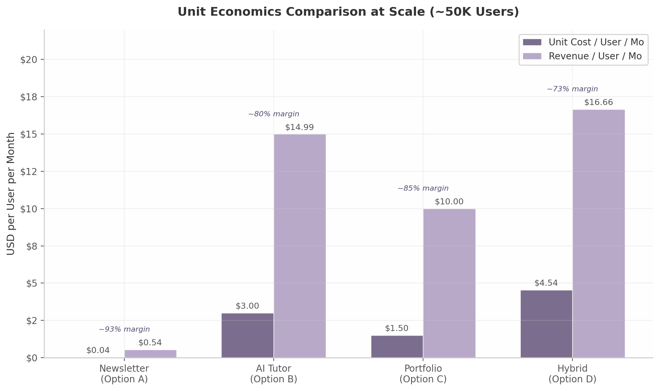
Unit Economics Comparison
Figure 2.1: Unit economics comparison at approximately 50,000 users. The newsletter achieves exceptional margins due to near-zero marginal cost, while the hybrid’s higher cost base reflects the combined infrastructure of three product layers. Revenue estimates assume blended monetization (ads + subscriptions for newsletter; pure subscription for tutor; freemium + employer fees for portfolio; blended subscription for hybrid).

3. Decision Matrix & Scoring
The preceding chapters established what the market lacks and what each product architecture could offer. This chapter converts those qualitative assessments into a quantitative framework. A weighted scoring matrix across six criteria — calibrated to the realities of a pre-revenue startup entering a $93 billion competitive arena — produces a ranked recommendation and a phased build roadmap that maximizes learning per dollar spent.

3.1 Scoring Framework
Six criteria capture the dimensions that matter most for an early-stage product decision. Each is scored 1–5, with weights reflecting survival priorities for a capital-constrained startup.
Time to Market (20%). Speed to a live product generating user feedback is the dominant variable for a pre-revenue startup. Every week without market validation increases burn and decreases the probability of finding product-market fit.
Defensibility (20%). Long-term competitive protection — through data network effects, brand trust, and switching costs — determines whether traction can be retained. This matters enormously, but not at the expense of reaching the market.
Monetization Speed (20%). The interval between launch and first revenue signals business model viability. For a startup without venture backing, this must be measured in weeks. Products monetizable through advertising or affiliates before reaching scale score highest.
Strategic Optionality (15%). The degree to which a first product enables second and third products determines long-term value ceiling. A newsletter that evolves into a tutoring platform offers more optionality than a portfolio product requiring massive scale before any adjacent feature becomes viable.
Market Size (15%). All four options operate within multi-billion-dollar segments; differences between a $5 billion and $17 billion TAM matter less at MVP stage than speed and monetization clarity.
Technical Complexity (10%). Inverted in scoring: lower engineering risk receives higher marks. The modest weight reflects that technical challenges are solvable with capital, whereas market timing advantages are not.
Criterion | Weight | Rationale
Time to Market | 20% | Feedback velocity determines survival for pre-revenue startups
Defensibility | 20% | Long-term moat protects gains once traction is achieved
Monetization Speed | 20% | Weeks-to-revenue matters more than TAM at MVP stage
Strategic Optionality | 15% | First product must enable second and third products
Market Size | 15% | All options address multi-billion-dollar segments
Technical Complexity | 10% | Engineering risk is solvable; market risk is not
The weighting prioritizes operational execution over theoretical upside. A startup can recover from a thinner moat or smaller initial market; it rarely recovers from running out of capital before finding product-market fit. The equal 20% weights on Time to Market, Defensibility, and Monetization Speed reflect this survival-first logic.

3.2 Option Scoring
Criterion | Weight | Newsletter | AI Tutor | Portfolio | Hybrid
Time to Market | 20% | 5 (4–6 weeks) ³⁹ | 2 (12–16 weeks) | 3 (8–12 weeks) | 1 (20–28 weeks)
Defensibility | 20% | 2 (thin moat; switchable in 60 sec) | 5 (data flywheel) | 3 (network effects at scale) | 4 (bundle lock-in)
Market Size | 15% | 4 ($17.8B by 2028) ⁴ | 4 ($9.15B) ² | 3 ($5.8B) ³ | 5 (spanning all three)
Monetization Speed | 20% | 5 (ads + affiliates from Day 1) ⁴² | 2 (requires proven gains) | 1 (needs employers first) | 3 (newsletter layer early)
Technical Complexity | 10% | 5 (RAG + email pipeline) ³⁸ | 2 (pedagogical AI) | 3 (portfolio infra) | 1 (three stacks at once)
Strategic Optionality | 15% | 4 (upsell to tutor → portfolio) ⁷⁶ | 5 (adds newsletter + portfolio) | 2 (limited without users) | 5 (all integrated)
Weighted Total | 100% | 4.10 / 5.0 | 3.35 / 5.0 | 2.45 / 5.0 | 3.40 / 5.0
The newsletter-as-wedge scores 4.10 out of 5.0, a decisive margin over the hybrid (3.40) and tutor-first (3.35) approaches. The portfolio-first strategy trails at 2.45, confirming that distribution must precede any marketplace product.
The newsletter’s advantage concentrates in the three highest-weighted criteria. Its Time to Market score reflects that production-tested open-source implementations of RAG-based newsletters exist, and rasa.io has proven 1 million unique daily emails at scale ³⁸. Its Monetization Speed derives from AI newsletter CPMs of $20–$50 ⁴²and tool affiliate commissions of 20–45% recurring ⁴⁴, requiring no minimum scale to activate. The Technical Complexity score acknowledges this is the only option a small team can build and operate without ML engineers or pedagogical experts.
The newsletter’s critical weakness is defensibility, scored at 2. A subscriber can switch to a competitor in approximately 60 seconds, and the RAG-plus-summarization logic is replicable by any competent team — beehiiv’s Dynamic Content already approaches segment-level personalization ³⁷. This thin moat is why the phased roadmap adds tutor and portfolio layers: the newsletter acquires the audience; subsequent layers create the switching costs that retain it.
The AI tutor scores highest on defensibility (5) and strategic optionality (5) but is dragged down by Time to Market (2), Monetization Speed (2), and Technical Complexity (2). The evidence for AI tutoring efficacy is robust — 0.23 to 1.3 standard deviation gains across RCTs ⁵⁵, with Google’s LearnLM outperforming human tutors ⁵⁴— yet building pedagogical AI that demonstrably beats ChatGPT for professional skills demands 12–16 weeks by a team with learning science expertise. Duolingo achieved only ~9% Max penetration after years of testing ⁵⁹, suggesting even best-in-class products face long conversion funnels.
The hybrid scores respectably at 3.40, driven by perfect Market Size (5) and Strategic Optionality (5) scores. But it is critically weakened by Time to Market (1) and Technical Complexity (1): three distinct product stacks with distinct engineering paradigms and success metrics exceed what a pre-revenue startup can deploy. Its $49.99 price point, 67% above Duolingo Max ⁶³, further suppresses monetization velocity. The portfolio-first approach at 2.45 suffers the fundamental sequencing problem that killed Triplebyte — a portfolio without users is worthless to employers, and without employers, users have no incentive to build profiles ⁷⁰.
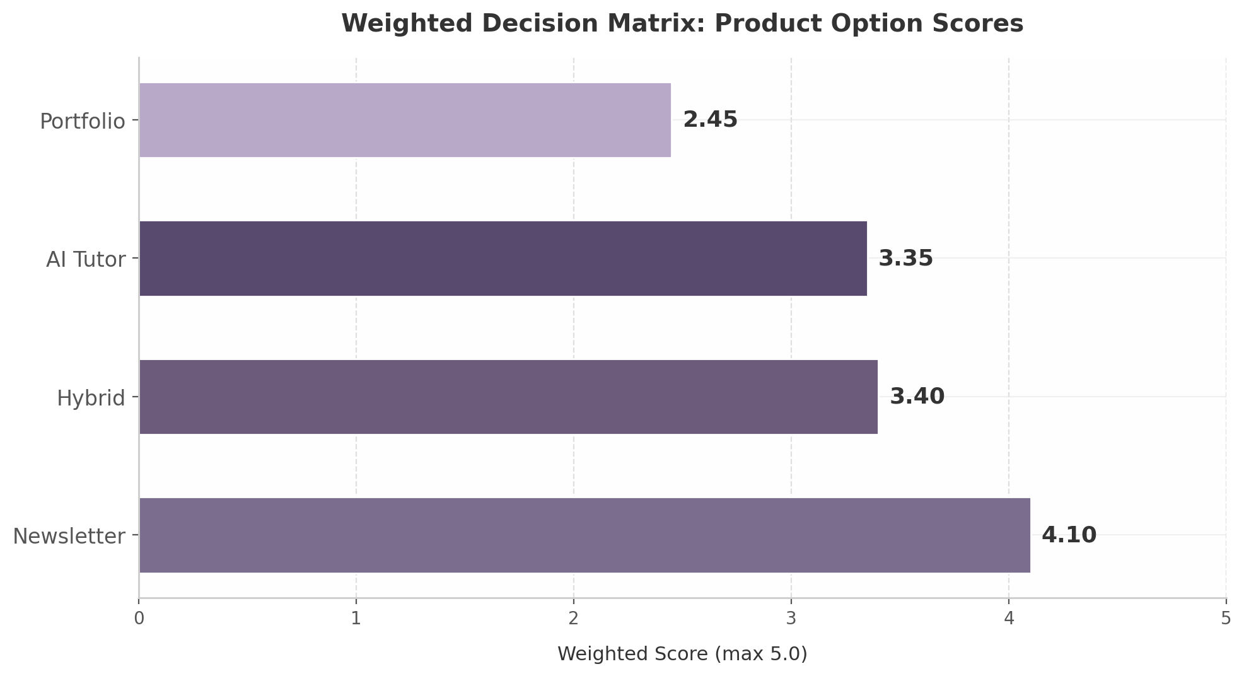
Weighted Decision Matrix
Figure 3.1 — Weighted scores across four product options. Newsletter-as-wedge (4.10/5.0) outperforms hybrid (3.40), tutor-first (3.35), and portfolio-first (2.45) by a margin driven by advantages in time to market, monetization speed, and technical feasibility.

3.3 Recommended MVP Path
The scoring matrix points to a clear sequence: launch with the newsletter, add the tutor layer to engaged subscribers, and introduce portfolio features only after learning outcomes are demonstrated.
Phase 1 (Months 1–3): Launch Career-Specific Newsletter. The MVP is a daily AI briefing personalized by career vertical — starting with 2–3 roles such as “AI for Performance Marketers,” “AI for Product Managers,” and “AI for Operations Leads.” A RAG pipeline over 30–50 curated sources feeds GPT-4o-mini for generation at roughly $0.001 per email ⁴⁶, with Amazon SES handling delivery. The product is operational in 4–6 weeks ³⁹, with monetization beginning immediately through sponsor placements at $20–$50 CPM ⁴²and AI tool affiliate recommendations. The Phase 1 milestone is 5,000–10,000 engaged subscribers with open rates above 40%, validating that career-specific personalization drives materially higher engagement than generic briefings. Advertising plus affiliate revenue at this scale is projected at $3,000–$8,000 monthly — enough to cover infrastructure costs and extend runway before any subscription revenue.
Phase 2 (Months 4–9): Add AI Tutor Layer for Engaged Subscribers. Once daily newsletter engagement is validated, an AI tutor is introduced as a premium upgrade for the most active subscribers — those consistently opening emails, clicking tool recommendations, and engaging with embedded tutorials. The tutor leverages the newsletter’s existing RAG corpus, extending it into interactive Socratic dialogue informed by Google’s LearnLM research ⁵⁴. Integration creates a seamless loop: a subscriber reads about a new AI tool in the morning briefing, practices with the tutor at midday, and receives a follow-up tip the next day based on interaction patterns. Pricing aligns with Duolingo Max at approximately $29.99 per month ⁶³, with a reverse trial granting free tutor access to engaged readers. The Phase 2 milestone is 500–1,000 paying tutor users with weekly engagement above 3 sessions and measurable skill progression.
Phase 3 (Months 10–18): Launch Portfolio and Employer Portal. With thousands of newsletter subscribers and hundreds of active tutor users generating learning data, conditions for a portfolio feature are finally met. The portfolio captures “build logs” — timestamped records of AI-assisted work including prompts used, tools employed, and outcomes achieved — that subscribers accumulate through newsletter-guided projects and tutor-assisted practice. This aligns with the structural shift toward skills-based hiring: 40% of companies have removed degree requirements and 73% of employers now use skills-based practices ⁷¹ ⁷². The employer portal opens only after 10,000+ active users with verified skill signals are on the platform, avoiding the chicken-and-egg problem that killed Triplebyte. Employer access is priced as a B2B subscription, creating a second revenue stream monetizing the data flywheel built over 9–12 months.
The Retention Flywheel. The phased architecture creates a self-reinforcing engagement loop no single-product competitor can replicate. The daily newsletter establishes habitual content consumption — the same mechanism driving Duolingo’s 52.7 million daily actives ³³and The Rundown’s 2 million subscribers at ~50% open rates ²¹. Tutor engagement deepens this into active skill practice, with each session generating progress data that increases switching costs. Portfolio documentation converts practice into employer-visible proof, giving subscribers career incentive to maintain activity. Employer interest in verified signals feeds back into motivation: the more employers browse portfolios, the more valuable each subscriber’s build log becomes. This flywheel — daily newsletter habit → tutor engagement → portfolio proof → employer interest → subscriber motivation — is the ultimate defensibility. It rests not on any single feature but on compounding learning data that deepens with every interaction.

4. Pricing & Business Model Recommendations

4.1 Pricing Benchmarks
The B2C EdTech subscription market clusters tightly in the $10–$40 per month band, and the current $49.99 price point sits above every major comparable platform. Duolingo Max—the company’s AI-powered tier offering personalized tutoring via GPT-4—costs $29.99 per month ($14 per month when billed annually), while its standard Super Duolingo tier runs $12.99 per month ⁶³ ⁸². Codecademy Pro, which combines skill-based learning with AI-assisted coding help, charges $39.99 per month on monthly billing ⁶⁴. Coursera Plus, offering unlimited access to 7,000+ courses and professional certificates from 200-plus university partners, costs $399 per year—equivalent to $33 per month ⁸⁰. Even specialized AI learning tools like Pictory AI ($19 per month) and HeyGen ($25 per month) price below the $30 threshold ⁸³. The global AI-in-education market reached $5.88 billion in 2024 and is projected to hit $32.27 billion by 2030, yet consumer willingness to pay has not expanded proportionally; B2C ARPU remains anchored at $10–$50 per month across the industry ⁸⁴ ⁷⁹.
The market landscape makes the pricing problem concrete. The user’s current $49.99 per month positions the product 67% above Duolingo Max—the most directly comparable AI tutoring product—and 25% above Codecademy Pro, which offers a decade of curriculum depth and brand trust. In EdTech, where the median freemium-to-paid conversion rate hovers at just 2–5%, every dollar above market anchors suppresses both trial-to-paid conversion and long-term retention ⁸⁵. The most successful platforms follow Duolingo’s philosophy of “charging for convenience, not content”—keeping core learning free while monetizing premium features such as unlimited AI interactions, advanced personalization, and ad removal ⁸⁶. This model enabled Duolingo to grow its MAU-to-premium conversion from 3% in 2020 to 8.8% by 2024, a 176% increase that now supports 10.3 million paid subscribers ⁸⁵ ⁷⁵.
The following table benchmarks the user’s current pricing against established market anchors across learning categories:
Platform | Monthly Price | Annual Price | Annualized Monthly | Core Value Proposition
Kahoot! Premium+ | $15.00 | $108 | $9.00 | Gamified learning, analytics ⁸⁰
Super Duolingo | $12.99 | $84 | $7.00 | Unlimited hearts, no ads ⁸²
InVideo AI | $15.00 | N/A | $15.00 | AI video creation ⁸³
Pictory AI | $19.00 | N/A | $19.00 | AI video summarization ⁸³
Duolingo Max | $29.99 | $168 | $14.00 | AI tutor (GPT-4) ⁶³
Coursera Plus | N/A | $399 | $33.25 | 7,000+ courses, certificates ⁸⁰
Codecademy Pro | $39.99 | $239.88 | $19.99 | Skill paths, AI coding help ⁶⁴
Current (My AI Skill Tutor) | $49.99 | N/A | $49.99 | AI tutor + newsletter + skills
The data reveal a clear pricing ceiling at approximately $40 per month for standalone B2C learning subscriptions. Codecademy Pro represents the upper bound of what consumers routinely pay for skill-based learning without the backing of university credentials or employer reimbursement. At $49.99, the product enters the psychological territory of $50—a left-digit threshold that consumers perceive as meaningfully more expensive than $49 or $39.99, even when the nominal difference is small ⁸⁷. Research on charm pricing consistently shows that prices ending in .99 outperform round numbers, but the left-digit effect means $49.99 reads as “forty-something” while $50.00 reads as “fifty”—a perceptual gap larger than the one-cent difference ⁸⁷. The recommended restructuring introduces a Newsletter tier at $19.99 per month, which aligns with Pictory AI and other AI productivity tools, and a Full Platform tier at $29.99 per month, matching Duolingo Max and sitting comfortably below the Codecademy ceiling. An annual plan at $299 per year offers a 17% discount over monthly billing, which uses the retention-based pricing formula proven during Codecademy’s growth from $10 million to $50 million ARR: Annual Price equals Monthly Price multiplied by average retention in months plus one ⁸⁸. If monthly subscribers average four months of retention, a five-month annual equivalent ($149.95) captures 25% more lifetime value than the monthly plan while presenting a compelling savings narrative to the customer ⁸⁸.

4.2 Revenue Model
A subscription-first architecture with layered monetization offers the most durable path to profitability in consumer EdTech. The primary revenue stream should remain the monthly subscription, but three overlay channels—affiliate commissions, newsletter advertising, and B2B licensing—can contribute meaningfully before the subscriber base reaches scale. AI tool affiliate programs offer commissions of 20–45% on recurring revenue, with programs like Copy.ai paying 45% of first-year revenue and Jasper AI offering 25–30% recurring for twelve months ⁴⁴. A 20% recurring commission on a $50 per month AI tool subscription generates approximately $120 over a year, compared to just $19.60 from a one-time 30% payout on the first month alone ⁴⁴. For a product that recommends career-specific AI tools—coding assistants for developers, writing tools for marketers, design AI for creatives—this commission layer can add $2–$5 per subscriber per month in incremental revenue before any subscription payment is collected.
Newsletter advertising becomes viable at approximately 25,000 engaged subscribers, where AI and technology newsletters command CPMs of $20–$50 ⁴². Top B2B AI newsletters charge $6–$8 per click for sponsored links, and newsletters targeting decision-maker audiences can achieve $50–$150 CPMs ⁴². Revenue per subscriber in the newsletter industry typically ranges from $0.10 to $1.00 per month, with B2B newsletters at the higher end due to advertiser demand for professional audiences ⁸⁹. At 25,000 subscribers with a 45% open rate and $35 CPM, a single sponsored placement per issue generates roughly $394 per send; three placements weekly yield approximately $4,700 per month in advertising revenue alone. The global AI-in-advertising market is projected to reach $81.6 billion by 2033, growing at 28.4% annually, which means advertiser demand for AI-interested audiences will continue expanding faster than newsletter supply ⁴².
B2B employer licensing represents the highest-margin Phase 2 revenue layer. Enterprise L&D contracts command $1,000–$2,000 per month with 90% annual retention, dramatically outperforming B2C EdTech’s typical 30–40% annual retention ⁷⁹. However, the B2C2B motion pioneered by Notion—where individual professionals adopt a product personally, embed it in their workflows, and pull it into their organizations—offers the most realistic path to enterprise revenue. By 2025, more than 50% of Fortune 500 companies used Notion, including OpenAI, Figma, and Salesforce, yet the company built this enterprise penetration on a foundation of individual user adoption rather than top-down sales ³⁷. For the AI skill tutor, this means individual subscribers who build visible skill portfolios become natural advocates for employer-sponsored team licenses. The timing matters: B2B SaaS sales cycles have expanded to 6.5 months on average, with enterprise deals exceeding $100,000 in ACV regularly taking 90 to 180 days to close ⁹⁰. Until the B2C product reaches 50,000-plus active users with demonstrable skill outcomes, employer licensing should remain a landing page and waitlist, not an engineering priority.

4.3 GTM Strategy
The optimal go-to-market strategy follows a product-led growth (PLG) flywheel anchored by a free newsletter tier that funnels engaged readers toward the paid tutor upgrade. Duolingo’s growth mechanics provide the template: the company achieved 130 million monthly active users and 52.7 million daily active users by leading with free, habit-forming content and monetizing only after users demonstrated engagement ⁷⁵ ⁹¹. Freemium conversion benchmarks suggest that most B2C apps convert 2% of free users to paid, while exceptional products reach 4–5% ⁸⁵. Duolingo’s 8.8% conversion rate—approaching the 10–15% rates seen in dating apps like Tinder and Bumble, which CEO Luis von Ahn cited as his aspirational benchmark—was achieved through contextual upgrade prompts tied to specific feature access, which convert 3–5 times higher than generic “Upgrade Now” buttons ⁸⁵ ⁹². The user should implement contextual gating: when a free newsletter subscriber attempts to access an AI tutor session, hits a saved-tutorial limit, or requests a personalized learning path, the platform surfaces an upgrade prompt tied to that specific need rather than a generic paywall.
Content-led acquisition should focus on SEO targeting high-intent queries such as “AI for [career]” and “best AI tools for [profession],” where the product’s career-specific differentiation creates natural ranking advantages. Duolingo conducts over 750 A/B tests per quarter to optimize its onboarding funnel ⁷⁵; the user should adopt a similarly iterative approach to landing pages and sign-up flows. Social proof from early users—documented skill improvements, workflow efficiencies, and career outcomes—becomes the most credible acquisition asset once the first 100 paid subscribers demonstrate measurable progress. EdTech LTV-to-CAC ratios average 5:1 with $7,100 LTV and $1,431 CAC, significantly healthier than the general SaaS benchmark of 3:1, which provides headroom for content investment ⁹³. PLG-driven self-serve models achieve CAC of $50–$200 compared to $1,200–$5,000 for enterprise SaaS ⁴¹, making newsletter-driven PLG the capital-efficient choice for early-stage growth.
The critical retention milestone is the 10-day streak. Duolingo’s data showed that users who complete lessons for 10 consecutive days experience dramatically lower dropout rates, and users who establish weekly habits convert to paid tiers at 3–4 times the rate of sporadic users ⁹⁴ ⁹². Capability milestones—celebrating “You can now…” achievements rather than content completion—drive even stronger retention: one EdTech platform improved 30-day retention from 15% to 50% by switching from content milestones to capability milestones, and users who hit three or more capability milestones were 6.2 times more likely to be active at day 90 ⁹⁵. The onboarding flow should be optimized obsessively for daily engagement in the first 10 days, using streak mechanics, daily AI briefings, and capability demonstrations as the hooks that transition a newsletter reader into a platform habit. Annual subscriptions should be promoted aggressively within this window, as annual subscribers demonstrate 3–5 times higher renewal rates than monthly subscribers, and defaulting the pricing page to annual—with clear savings visualization and a 30-day refund guarantee—can shift the revenue mix toward more predictable, higher-retention billing ⁸⁸.

5. Brand & Positioning Strategy
A product can have flawless unit economics and a defensible feature set and still stall if its brand fails to occupy a distinct mental slot. For myaiskilltutor.com, the brand challenge is acute: the current name communicates function without differentiation, and the existing positioning around “outlearn your peers” and fear of job loss sits at a strategic fork that demands resolution before a single dollar of paid acquisition is spent. This chapter assesses the current brand, evaluates three positioning alternatives, and maps a naming path that aligns the product with the daily habit it seeks to become.

5.1 Current Brand Assessment

5.1.1 Name Analysis: Functional but Generic at Four Syllables
“My AI Skill Tutor” scores highly on one dimension alone: immediate comprehension. A user encountering the name for the first time understands within seconds that the product involves AI, skills, and tutoring. Research on brand naming psychology confirms that “shorter words can be more concrete as a whole, familiar, and image-able” ⁹⁶, and descriptive clarity does lower cognitive load for first-time visitors. In the edtech landscape, clear names are a recognized pattern — MasterClass, Carnegie Learning, Skillshare, and Skillsoft all follow variants of this logic ⁹⁷.
The problem is that clarity without distinction is a commodity position. At four syllables, “My AI Skill Tutor” sits outside the two-syllable sweet spot that dominates top consumer brands — Apple, Google, Walmart, Shell ⁹⁶. Pathak et al. found that “individuals are faster to respond to shorter names due to the frequency of shorter words in the English language” ⁹⁶, making the current name neurologically slower to process. The “My” prefix adds no strategic value, and the “[Technology] + [Function]” construction reads as a feature description rather than a brand promise. Unlike Duolingo’s owl or Superhuman’s velocity framing, the name offers no personality hook — leaving the product vulnerable to being perceived as interchangeable with any ChatGPT wrapper.

5.1.2 The “Tutor” Problem: Episodic Connotation in a Daily Habit Market
The word “tutor” implies episodic interaction — a student schedules a session, absorbs material, and returns later. This is the wrong mental model for a product competing for a daily habit slot. Research clarifies: “A tutor transfers knowledge and checks understanding. A coach builds performance through practice and feedback” ⁹⁸. If the product’s core mechanic is daily micro-engagement — a brief lesson, a practice prompt, a skill check — then “coach” or “daily brief” are more accurate descriptors. The Mimic Minds analysis notes that “a lot of products call themselves a coach, tutor, and mentor at the same time,” creating confusion ⁹⁸. A name that commits to one role clearly stands out. Treat the current name as a working title for SEO validation, but plan evolution before product-market fit.

5.2 Positioning Alternatives
The product’s current messaging oscillates between two emotional registers — fear of job displacement and competitive peer comparison. To resolve this, we evaluate three positioning frameworks against quantitative evidence and project their long-term brand effects.
Dimension | Fear-Based (“Don’t Lose Your Job”) | Opportunity-Based (“Earn 10–20% More”) | Peer-Based (“Outlearn Your Competition”)
Core Mechanism | Threat avoidance; urgency through anxiety | Aspirational gain; growth mindset activation | Social comparison; competitive pride
CTR Performance | +70% vs. positive headlines ⁹⁹ | Baseline | +15–20% estimated
Long-term Loyalty | Low — anxiety decays, brand fatigue high | High — aligns with self-improvement identity | Medium — effective for ambitious segments only
Brand Association Risk | High — consumers associate fear feelings with brand ¹⁰⁰ | Low — positive affect transfer | Medium — competitive framing alienates collaborative learners
Best Funnel Stage | Awareness (hook) | Consideration → Conversion → Retention | Conversion reinforcement
Audience Breadth | Broad — 55% believe AI will eliminate more jobs than it creates ⁴¹ | Broad — 52% of young adults worry about career impact ¹⁰¹ | Narrow — appeals primarily to competitive professionals (tech, finance, consulting)
Key Data Point | Only 2% of ads are negative, creating standout potential ¹⁰⁰ | AI-skilled workers earn 10–20% above counterparts ¹⁰² | High-loyalty firms grow revenue 2.5× faster than peers ¹⁰³
Recommended Usage | Sparingly — opening hook only | Primary messaging architecture | Social proof layer for competitive segments
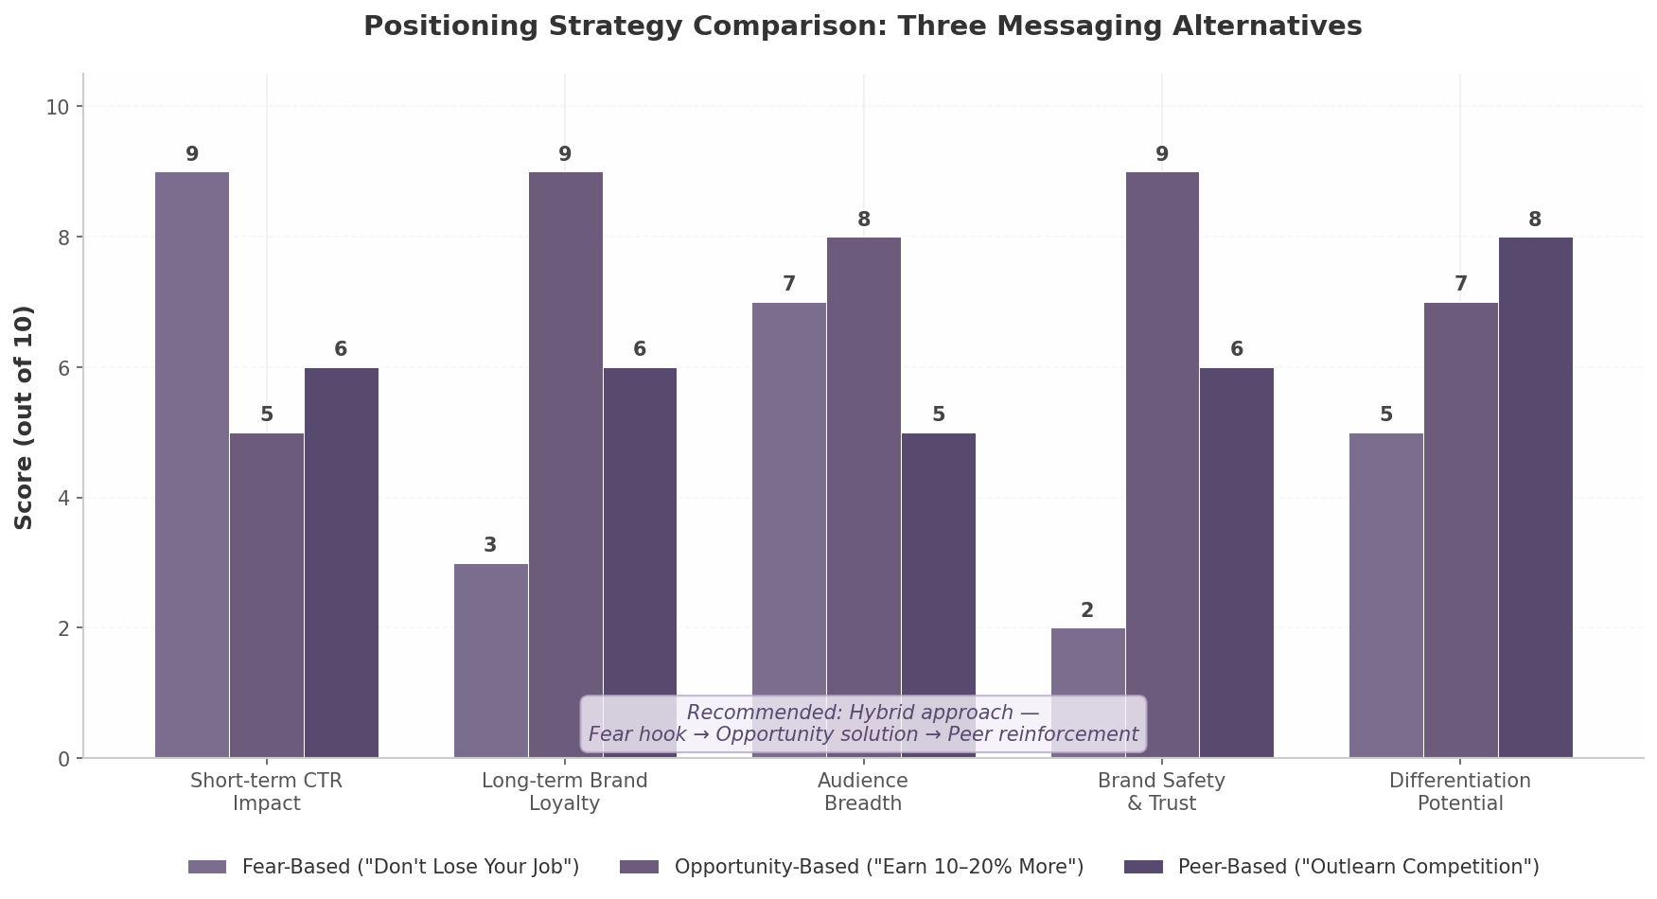
Positioning Strategy Comparison
The pattern is clear: no single framework dominates. Fear delivers superior short-term click-through — 70% higher CTR and 18.8% higher conversion in controlled experiments ⁹⁹— but “if your messaging is causing consumers to feel anxious and afraid, there’s a good chance they’re going to associate those feelings with your brand” ¹⁰⁰. With only 2% of ads employing negative framing, fear cuts through clutter but leaves a residue.

5.2.1 Fear-Based Positioning: High CTR, High Risk
The fear narrative is factually grounded: 55% of people believe AI will eliminate more jobs than it creates, and 52% of young adults aged 18–24 worry about negative career impact ⁴¹. Females and the 18–29 cohort report significantly higher fear than other demographics ¹⁰¹, creating a large addressable audience motivated by threat avoidance. The danger is brand dilution over time — a product positioned as “the thing that reminds you AI might take your job” becomes emotionally taxing to engage with daily. Users churn not because the product fails but because the brand experience itself is unpleasant. Deploy fear as an entry hook, never as a retention architecture.

5.2.2 Opportunity-Based Positioning: The Long-Term Play
Opportunity-based messaging reframes AI skills as a career accelerator. PwC research found that even highly automatable roles saw 38% job growth between 2019 and 2024 ¹⁰⁴, and AI-skilled workers typically earn 10–20% more than counterparts in traditional roles ¹⁰². This framework builds long-term brand affinity by aligning with the user’s aspirational self-image — the same mechanism that makes fitness and wellness brands sticky. Research confirms that “a balanced approach is often the best strategy” — leading with hope and following with empowerment outperforms sustained fear ¹⁰⁵.

5.2.3 Peer-Based Positioning: Segmented Effectiveness
The “outlearn your competition” framing targets ambitious professionals in technology, finance, and consulting — industries where relative skill advantage translates directly to career outcomes. Businesses with high brand loyalty grow revenue 2.5 times faster than peers ¹⁰³. However, competitive framing risks alienating users who prefer collaborative environments. Treat peer-based messaging as a reinforcement layer for competitive segments, not as the primary architecture.
Recommended hybrid: Lead with opportunity, use fear sparingly for urgency hooks, and reinforce with peer social proof. This maps each framework to its highest-return funnel stage.

5.3 Naming Considerations

5.3.1 Direction: Shorter, Active, Habit-Oriented Names
The naming objective is to signal daily utility rather than episodic education. The product competes for a morning routine slot — the same slot Morning Brew occupies with “become smarter in just 5 minutes” ¹⁰⁶and Superhuman owns with “get smarter about AI in 3 minutes a day” ¹⁰⁷. The name should feel like a daily ritual, not a semester commitment.
Research on 300+ edtech companies reveals five dominant naming patterns: short and catchy (Udemy, Guild — two syllables max); clear and descriptive (MasterClass, Coursera); dictionary words (Skillshare, Degreed); personal names (Mimo, Sana); and suffix trends —ly, -able, -ify (Amplify, Teachable, Brainly) ⁹⁷. The strongest path combines short, action-oriented dictionary words or compounds that communicate ongoing competitive advantage. Four directions merit exploration: action-oriented compounds (SkillStack, UpSkillr) that risk sounding like tools; aspirational single words (Edge, Alto) that require marketing investment; brand name + tagline (“ALMA: Your Daily AI Career Coach”) following the Duolingo model; and time-based promise names (“The AI Brief,” “5-Minute AI”) leveraging the proven newsletter positioning that Morning Brew ($70M revenue) ¹⁰⁶and Superhuman (1M+ subscribers) ¹⁰⁷validated. One critical finding: “Outlearn” was previously used by a developer learning platform funded by General Catalyst Partners ³⁹, creating trademark and SEO risk.

5.3.2 Patterns from Successful Brands
Three case studies offer directly applicable lessons. Duolingo (59 million monthly active users) ¹⁰⁸demonstrates that brand personality can be the primary differentiator — CEO Luis von Ahn estimated that roughly 15% of new users arrive because of “some sort of owl thing” ¹⁰⁹. A mascot creates emotional connection that no feature set can replicate. Section (formerly Section4) provides the most relevant rebrand blueprint. After growing to 20,000 students, the company dropped the “4” because the original meaning had become a liability ¹¹⁰, evaluating against three hurdles — Relevance, Differentiation, Sustainability — and scoring their old brand B+ on relevance but D on differentiation ¹¹¹. For myaiskilltutor.com, the equivalent scores would likely be Relevance A-, Differentiation D, Sustainability C. Morning Brew proves that a daily brief format scales to $70 million in revenue with 4.4 million subscribers and 50%+ open rates ¹⁰⁶. The brand name encodes the promise: a daily ritual (morning) that is actionable (brew). Any new name should achieve the same semantic compression.

5.3.3 Domain Strategy: Secure Both .com and .ai; Avoid Add-On Words
The domain extension decision carries both consumer trust and investor credibility implications. Seventy percent of U.S. consumers implicitly trust .com domains, while .ai’s trust rating reaches only 34% even among its strongest demographic (ages 35–54) ¹¹². Critically, 98% of investors say lacking a .com affects pitch credibility ¹¹². At the same time, .ai registrations grew from 50,000 in 2018 to over 600,000 by early 2025, with a record $700,000 sale for you.ai ¹¹³— signaling that .ai has established legitimacy for AI-native brands.
The recommended strategy: secure both extensions, using .ai as the primary product domain (signals innovation, better availability) while holding .com defensively. A critical constraint: research shows “an AI company’s credibility was harmed for 96% of customers when an add-on word (other than AI) was used in the domain name” ⁷⁶. If the ideal .com is unavailable, a distinctive brand with clean .ai presence outperforms a compromised .com with add-on words. Viable patterns include [Word].ai (edge.ai, brief.ai), [Verb]+[Word].com, and [Compound].ai (skillstack.ai). Secure domains in parallel with name selection — not as an afterthought.

6. Strategic Recommendations & Next Steps
The preceding analysis converged on a single verdict: newsletter-as-wedge outperforms all alternative configurations at 4.1 out of 5 on the weighted decision matrix, driven by its unmatched combination of low capital requirements, rapid feedback loops, and a compounding data flywheel ²². The $93 billion combined TAM across AI career coaching, personalized learning, skills assessment, and newsletter advertising creates sufficient headroom for phased expansion from a single vertical into a multi-sided platform ¹ ² ³. The 18-month execution roadmap below translates this strategic choice into discrete actions with milestones, resource priorities, and risk mitigations.

6.1 Immediate Actions (Next 30 Days)

6.1.1 Pivot to Newsletter-as-Wedge: Define 2–3 Initial Career Verticals
The first 30 days should narrow the audience to the most underserved segment. Eighty-eight percent of generative AI users are non-technical — spanning marketing, product management, operations, sales, and HR — yet virtually every skills platform targets developers ¹⁰. This mismatch is the wedge. The team should select two to three verticals based on audience accessibility through existing communities, visible AI tool adoption curves, and affiliate commission density. Performance marketing, product management, and operations are the strongest initial candidates: each has a well-defined tool stack, active practitioner communities, and 20–45% recurring affiliate commissions ¹². The newsletter should be positioned around daily utility rather than education — habit-forming products consistently outperform episodic “tutors” on retention metrics ⁶.

6.1.2 Reduce Pricing to $29.99/mo; Introduce $19.99/mo Newsletter-Only Tier
The current $49.99 monthly price sits above every major B2C learning platform except premium cohort courses. Duolingo Max, the most comparable AI-native tutor, commands $29.99 per month; Codecademy Pro is $39.99; Coursera Plus breaks down to roughly $33 monthly ⁸ ⁹. At $49.99, the product faces a conversion headwind before users experience value. The recommended restructuring introduces a $19.99 tier for the newsletter alone, $29.99 for the full platform with AI tutor access, and a $299 annual plan with a 17% effective discount. Given the 3.8% median monthly churn rate in EdTech, every pricing optimization that extends subscriber lifetime has outsized impact on lifetime value ¹¹.

6.1.3 Build Minimal Personalized Newsletter MVP Using RAG + LLM Pipeline
The MVP should center on a RAG + LLM pipeline that ingests daily AI news, research, and product launches, then restructures content into career-specific briefings. Per-email generation costs range from $0.001 to $0.01, enabling net margins of approximately 93% at 50,000 subscribers ⁷. The rasa.io platform demonstrates that one million uniquely personalized emails can be delivered daily for under $500 ²⁰. The engineering priority is consistency — a daily email that arrives at the same time, with the same structure, tailored to the recipient’s vertical and skill interests. The product must collect telemetry from day one: which links were clicked, which tools were favorited, which topics prompted unsubscribes. This data becomes the foundation of the personalization engine and, ultimately, the flywheel.

6.2 Medium-Term Priorities (Months 2–6)

6.2.1 Achieve 10,000 Engaged Newsletter Subscribers
The 10,000-subscriber threshold is the first non-negotiable validation milestone. At this scale, the business generates sufficient signal to distinguish high-engagement verticals from low-potential ones, and sufficient revenue to fund Phase 2. AI-focused newsletters achieve 40–55% open rates against a 21.5% industry average, indicating genuinely attentive subscribers in this niche ⁶. Growth should come from three channels: organic sharing (optimize for forward-to-a-colleague behavior), LinkedIn distribution (short-form excerpts), and targeted outreach to AI tool communities. The free-to-paid conversion target should be calibrated to 3–5% initially, rising to 8–10% as the AI tutor layer demonstrates value.

6.2.2 Integrate AI Tutor for Top 2 Career Verticals Based on Engagement Data
Once engagement data identifies the top two verticals, the AI tutor should be introduced as a reverse trial: newsletter subscribers receive limited tutor interactions before a paywall requires the $29.99 tier. Randomized controlled trials confirm AI tutoring achieves effect sizes of 0.23 to 1.3 standard deviations, with Google’s LearnLM outperforming human tutors in published studies ¹⁹. Critically, no dedicated AI tutor exists for working professionals — Khanmigo targets students; CoachHub AIMY serves enterprise contracts ¹⁹. The tutor should preserve the daily newsletter habit while adding on-demand support for skill gaps surfaced by behavior: if a subscriber consistently clicks articles about prompt engineering, the tutor should proactively offer a guided practice session.

6.2.3 Launch Affiliate Partnerships with 10–15 High-Value AI Tools
At 50,000 subscribers, conservative estimates place monthly advertising and affiliate revenue between $8,000 and $27,000 — potentially exceeding subscription revenue in early stages ²⁵. AI newsletters command CPMs of $20 to $50, and tool affiliate programs pay 20–45% recurring commissions ¹² ¹³. The first partnerships should target high-relevance tools in each vertical: content creation suites for marketers, workflow automation for operations, analytics platforms for product managers. Every recommendation should be tracked at the user level, both to measure affiliate attribution and to enrich personalization profiles.

6.3 Long-Term Vision (Months 6–18)

6.3.1 Build the Data Flywheel: Usage Data Improves Personalization
At month six, the architecture shifts from linear to compounding. Every interaction — email opens, tutor dialogues, tool clicks, lesson completions — refines the personalization model, which increases engagement, attracts more users, and generates more data. While AI-generated content is commoditized, per-user learning graphs showing skill progression over time cannot be replicated without a comparable user base ¹⁰. The engineering investment in analytics during months one through three pays its full return here: the quality of the flywheel is determined by the granularity of the data collected at the outset.

6.3.2 Launch Employer-Facing Skill Verification at 50,000+ Active Users
The employer portal is a Phase 3 feature because the talent marketplace model has a brutal chicken-and-egg problem — Triplebyte failed at it; Hired was absorbed into Adecco ²¹. Without verified learners, employers will not pay; without employer demand, learners will not build profiles. However, once the platform reaches 50,000 active users with verified skill progression, the employer portal becomes a natural B2B layer. LinkedIn’s trajectory validates this sequencing: build the audience first, monetize employers second ¹⁷. Forty percent of companies have removed degree requirements, and 74% of employers prefer verified digital credentials for AI roles ¹⁶ ¹⁸. The verification product should emphasize “proof of work” — documented workflows and outcome logs — rather than certificates, because applied evidence outweighs test completion in hiring decisions.

6.3.3 Expand to 10+ Career Verticals with Vertical-Specific AI Tutor Personalities
By month 14, the platform should support ten or more verticals, each with a distinct AI tutor personality calibrated to the profession’s communication norms. Expansion should follow engagement density: new verticals are added only when subscriber data from adjacent roles signals demand. Cohort-based communities — achieving 70–96% completion versus 12.6% for self-paced courses — should be layered as lightweight accountability structures ¹⁴. Skool’s AI category, with over 800,000 members across 170,000 communities, demonstrates practitioners will self-organize when given infrastructure ²⁴. Community moderation costs scale non-linearly at $3,000–$10,000 per month beyond 5,000 members, so AI-assisted moderation should be built into the architecture from launch.

6.4 Risk Factors
Risk Category | Risk Description | Probability | Impact | Mitigation Strategy
Competitive | Major newsletters add basic career filtering | Medium | High | Deep personalization via usage data; content curation moat ⁵
Technical | LLM API costs rise sharply | Medium | Medium | Hybrid architecture with local models; 93% margin buffer ⁷
Market | AI tools become zero-learning-required | Low | High | Pivot toward workflow integration and outcome documentation
Execution | 10K subscriber milestone not reached | Medium | High | Narrower vertical focus; increased paid acquisition
Retention | Monthly churn exceeds 3.8% benchmark | Medium | Medium | Daily streak mechanics; community accountability ¹¹ ¹⁵
Regulatory | AI tutor claims attract compliance scrutiny | Low | Medium | Avoid outcome guarantees; frame as guidance, not certification
The competitive risk warrants particular attention. The major AI newsletters — The Rundown, Superhuman, TLDR — collectively reach over 5 million subscribers and have demonstrated willingness to evolve formats ⁴. If any adds basic career-vertical filtering, first-mover advantage in personalization depth becomes the primary defense. This underscores the urgency of building the data flywheel early: a competitor can replicate content, but cannot replicate six months of individualized learning behavior without first acquiring a comparable user base. The LLM cost risk is manageable — even a 5x increase in per-email generation cost would leave gross margins above 60% ⁷. The most consequential market risk is a structural shift in which AI tools become so intuitive that professionals no longer need guided learning. This remains low probability: 77% of workers report AI has increased their workload, and 47% do not know how to achieve productivity gains from available tools ⁴. Demand for structured skill development is durable, though its specific form will evolve.
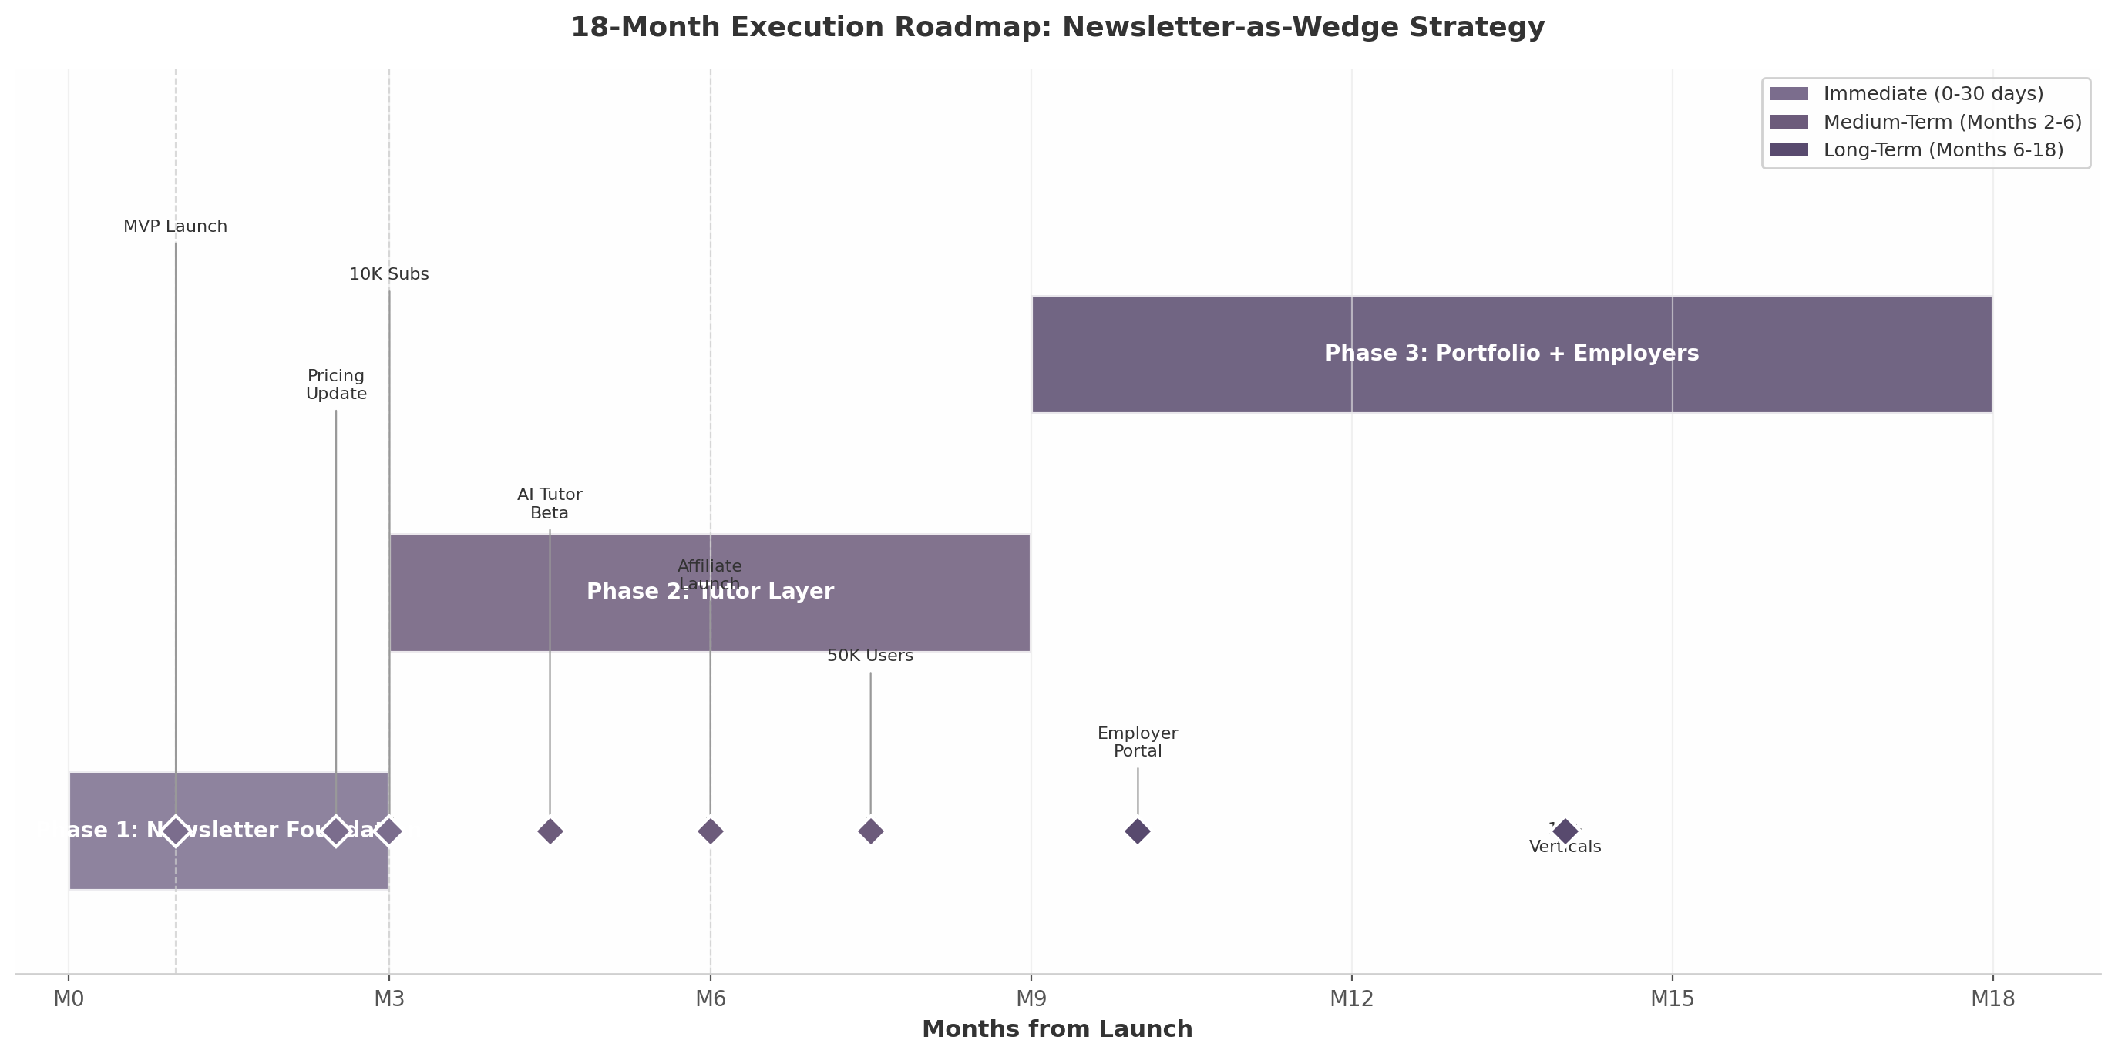
18-Month Execution Roadmap: Newsletter-as-Wedge Strategy
Figure 6.1: Phased execution roadmap showing the three-phase transition from newsletter foundation through tutor integration to employer-facing skill verification.
Phase | Timeline | Primary Objective | Key Deliverables | Validation Gate
Phase 1: Newsletter Foundation | Months 0–3 | Launch and validate career-specific daily newsletter | 2–3 verticals live; RAG pipeline operational; tiered pricing active | 10,000 engaged subscribers ⁶
Phase 2: Tutor Layer | Months 3–9 | Integrate AI tutor and monetization layers | Tutor for top 2 verticals; 10–15 affiliate partnerships; community beta | 50,000 active users; 8–10% paid conversion
Phase 3: Portfolio + Employers | Months 9–18 | Launch skill verification and employer portal | Employer-facing profiles; 10+ verticals; B2B revenue stream | 50,000+ users with skill progression data ¹⁸
Table 6.1: Summary roadmap with validation gates. Phase transitions are contingent on hitting engagement milestones, not calendar dates.
The power of this roadmap lies in its optionality. Phase 1 requires minimal engineering — a RAG pipeline, email delivery, and a landing page — yet generates the data and revenue to fund Phase 2. If the 10,000-subscriber gate is not reached by month three, vertical focus can be narrowed without a major capital write-off. If reached ahead of schedule, the tutor layer can accelerate. Each phase builds a compounding asset: subscribers become data, data becomes personalization, personalization becomes engagement, engagement becomes employer demand, and employer demand closes the retention flywheel by giving subscribers a tangible career incentive to maintain their streak. The newsletter is not the final product — it is the wedge that opens a market no competitor currently occupies.

